AI Meeting-to-Action Commander : GenAI-Powered Meeting Action Tracker - Gemini Model
Project Description:
AI Meeting-to-Action Commander is a full-stack meeting intelligence platform that converts meeting or video links into structured transcripts and actionable meeting insights. Users can sign in, select either a public YouTube video or a supported live meeting source, submit the link, and follow a processing workflow that produces a timeline transcript followed by decisions, action items, owners, deadlines, risks, unanswered questions, important topics, a meeting score, and an executive follow-up message. The frontend is implemented with React 18 and Vite, while the backend uses Node.js with Express. Meeting data is persisted in a JSON database through the store.js layer.
The application supports YouTube transcript extraction through the youtube-transcript package and can connect live Google Meet, Microsoft Teams, and Zoom sessions through a configured Skribby meeting-bot service. For analysis, the backend can use configurable Google Gemini models when a Gemini API key is available and validates the returned structured output. If the Gemini path is unavailable or produces invalid output, the application falls back to a local Precision Contextual NLP Engine that performs clause segmentation, decision detection, action-item extraction, owner and deadline identification, risk detection, deduplication, and post-processing.

Scenarios
• Scenario 1: A user pastes a public YouTube video URL. The system validates the link, retrieves the video metadata and public captions, groups caption fragments into a readable timeline transcript, performs language handling, and runs the meeting-intelligence analysis.

• Scenario 2: A user selects Google Meet, Microsoft Teams, or Zoom and submits a live meeting URL. When the meeting-bot service is configured, the backend dispatches a bot, tracks its status, and retrieves the completed transcript after the meeting ends.

• Scenario 3: A user opens the generated results and reviews decisions, action items, owners, deadlines, risks, and the meeting score. Action-item status can be updated and the follow-up message can be edited and saved.

• Scenario 4: A user asks a question about a completed meeting. The Ask AI route is grounded to that meeting's transcript and extracted intelligence; when Gemini is configured it is instructed to use only that meeting context, while a local contextual QA path is available as fallback.

Technical Architecture:
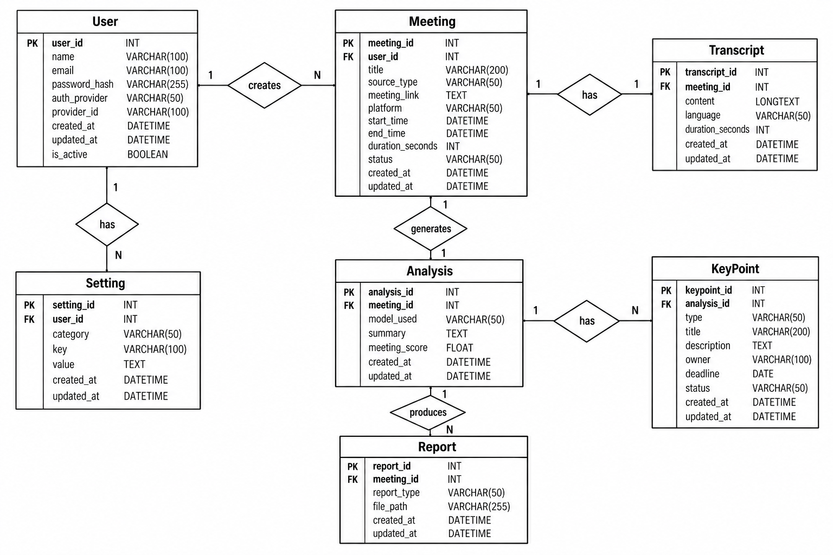

Pre-requisites:
• React: React Documentation
• Node.js: Node.js documentation
• JavaScript / JSX Skills: JavaScript documentation
• Gemini API Familiarity: Gemini API Documentation
• Ngrok for Public Deployment: Ngrok Documentation
• Meeting Bot Integration: Scribby documentation
• Git and Environment Configuration: Git Documentation
• Development Environment: Node.js Documentation

Project Workflow:

Activity 1: Architecture and AI Strategy
• Activity 1.1: Define the React frontend, Express backend, transcript services, AI analysis layer, and JSON persistence architecture.
• Activity 1.2: Define the analysis strategy using configurable Gemini models with a validated JSON schema and a Precision Contextual NLP fallback.
• Activity 1.3: Configure environment variables and install the project's npm dependencies.

Activity 2: Transcript and Meeting Ingestion
• Activity 2.1: Validate incoming URLs and detect YouTube, Google Meet, Microsoft Teams, or Zoom sources.
• Activity 2.2: Extract and structure public YouTube captions into a timestamped transcript, with optional translation handling.
• Activity 2.3: Dispatch and monitor a live meeting bot through the configured meeting-bot service.

Activity 3: Backend and Intelligence
• Activity 3.1: Implement REST API routes for authentication, meetings, transcript processing, analysis, bot management, updates, deletion, and Ask AI.
• Activity 3.2: Analyze transcripts for explicit decisions, future-oriented action items, owners, stated deadlines, risks, unanswered questions, and important topics.
• Activity 3.3: Persist meetings in the JSON database and expose structured results to the frontend.

Activity 4: Frontend Development
• Activity 4.1: Build login, home, transcript generation, processing, transcript review, results, meetings, calendar, reports, and settings pages.
• Activity 4.2: Connect the UI to backend APIs through MeetingContext and apiClient, including bot-status polling and result updates.

Activity 5: Testing and Deployment
• Activity 5.1: Test YouTube, live meeting, analysis, Ask AI, status updates, and persistence flows.
• Activity 5.2: Expose the application through the selected deployment/tunneling environment when required.
• Activity 5.3: Deploy the application publicly using Ngrok to expose the local Flask server over a secure public URL.

Activity 6: Conclusion

Milestone 1: Architecture and AI Strategy
This milestone establishes the overall architecture and the intelligence strategy used by the application. The system separates the user interface, API layer, transcript ingestion, AI analysis, and persistence responsibilities so that each stage can be tested independently.

Activity 1.1: Define the Application Architecture
The frontend is a React 18 application bundled with Vite. App.jsx controls page-level navigation and switches between the login screen, home dashboard, transcript workflow, results, meetings, calendar, reports, and settings. AuthContext manages the current user and authentication state, while MeetingContext manages meeting records, processing state, active bot sessions, transcript workflow, and result updates.
• Frontend layer: React pages and reusable layout/common components.
• State layer: AuthContext and MeetingContext coordinate authentication, meeting data, processing steps, bot status, and UI notifications.
• API layer: apiClient.js centralizes calls from the browser to the Express backend.
• Backend layer: server/index.js exposes REST endpoints and coordinates the service modules.
• Service layer: transcriptEngine.js, translationEngine.js, aiAnalyzer.js, and skribbyService.js implement ingestion, language handling, analysis, and live meeting integration.
• Persistence layer: store.js manages the JSON database used for users and meeting records.

Activity 1.2: Configure the AI Analysis Strategy
The primary analysis path is configurable. When GEMINI_API_KEY or a user-level Gemini key is available, the backend can call an allowed Gemini model and request structured JSON containing decisions, action items, and risks. The response is validated and sanitized before it is accepted. If the Gemini request fails or the output does not pass validation, the Precision Contextual NLP Engine is used instead.
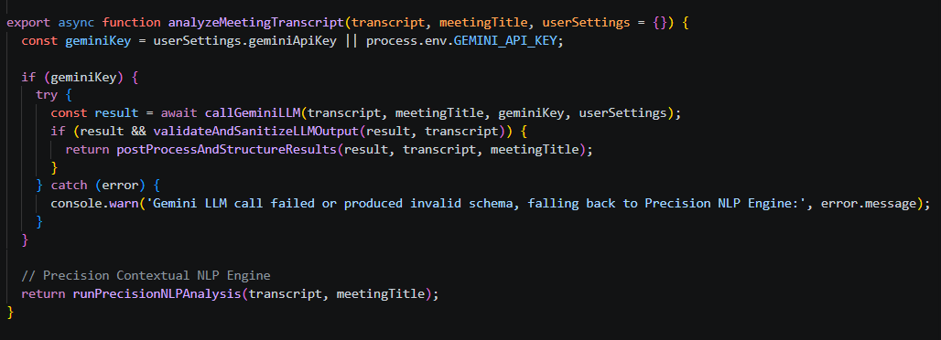

Activity 1.3: Install Dependencies and Configure Environment
The project is a Node.js application with a Vite React client and an Express server. The package.json defines concurrent development, server watch, client development, production build, and preview commands.

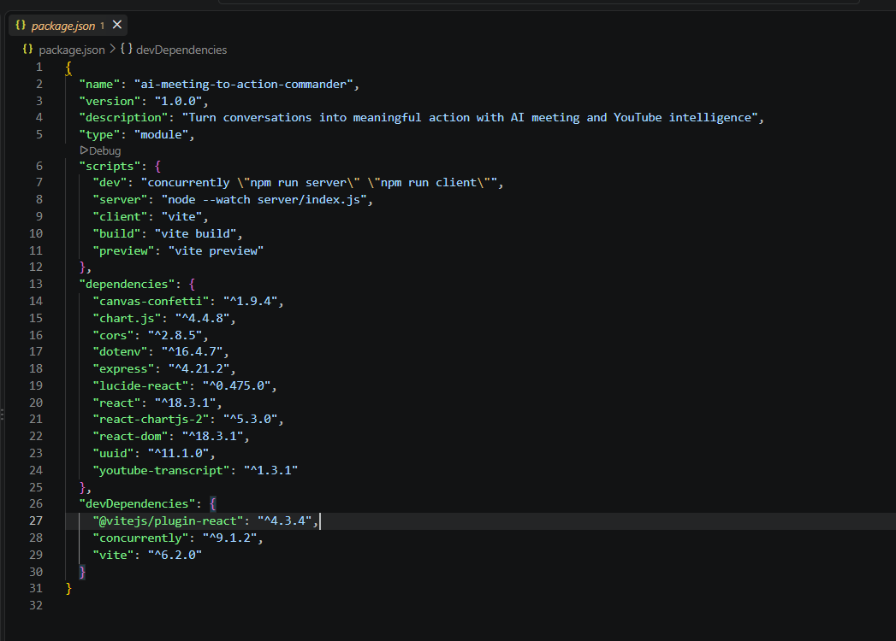

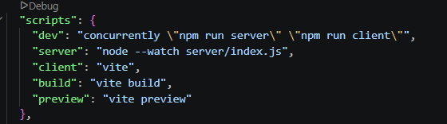

The environment file contains runtime configuration such as the server port, optional Gemini key, optional YouTube API key, meeting-bot provider, Skribby credentials, and webhook base URL. The documentation should show only .env.example-style placeholders; actual secret values must remain private.
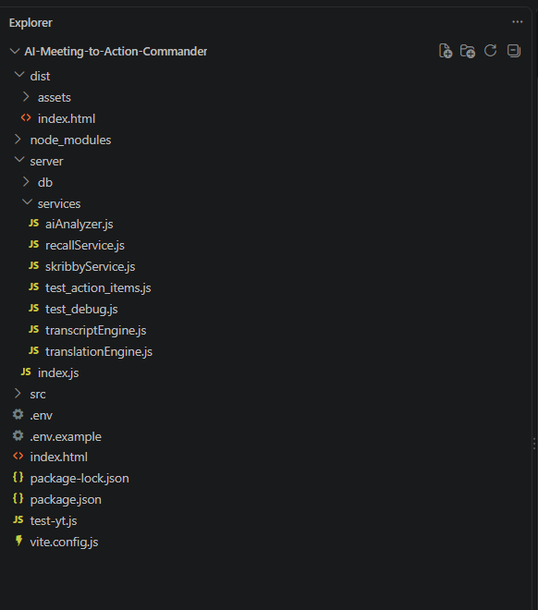

Milestone 2: Transcript and Meeting Ingestion
Milestone 2 focuses on collecting and processing meeting sources from YouTube and supported live meeting platforms. It validates meeting links, retrieves or generates transcripts, handles transcript content and metadata, and manages the live meeting bot workflow for Google Meet, Microsoft Teams, and Zoom. The processed transcript is then prepared and passed to the AI analysis module for extracting meaningful meeting insights such as decisions, action items, owners, deadlines, and risks.

Activity 2.1: Link Validation and Platform Detection
Before processing begins, the backend validates the submitted URL and determines whether it represents a YouTube source or a supported live meeting. YouTube URLs are parsed for a valid 11-character video ID. Live meeting links are checked against Google Meet, Microsoft Teams, and Zoom patterns. Invalid or unsupported URLs return a clear error response instead of entering the processing pipeline.
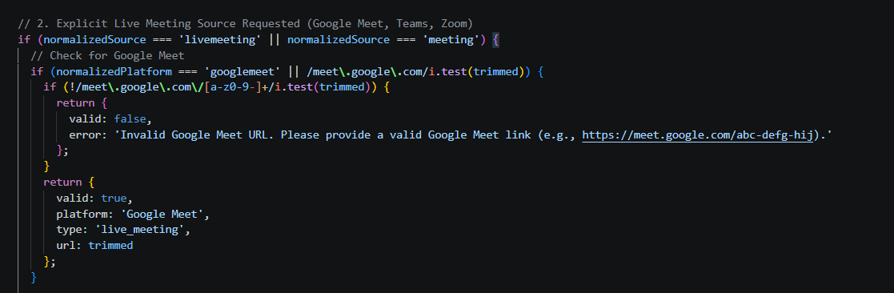

Activity 2.2: Extract and Structure YouTube Captions
For YouTube sources, transcriptEngine.js retrieves public caption items using the youtube-transcript package. The service decodes common HTML entities, removes unwanted line breaks, detects optional speaker labels, groups short caption fragments into larger timeline blocks, and calculates a readable duration. The resulting structure contains time, speaker, and text fields used by the analysis engine.

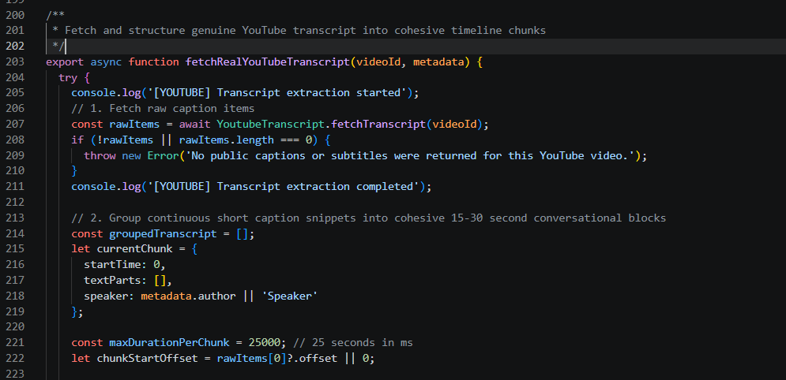

Activity 2.3: Connect Google Meet, Microsoft Teams, and Zoom
Live meetings use the configured meeting-bot integration. When a supported meeting URL is submitted and SKRIBBY_API_KEY is available, transcriptEngine.js calls the meeting-bot service and returns a bot session rather than pretending that a transcript already exists. The frontend stores the bot ID and polls its status while the meeting progresses.
• Supported sources: Google Meet, Microsoft Teams, and Zoom.
• Bot lifecycle: Joining, recording/in-call, processing/transcribing, finished, or failure/authentication states are reflected in the UI.
• Completion: When the bot has finished, the backend retrieves the transcript, runs the AI analyzer, and stores the completed meeting.

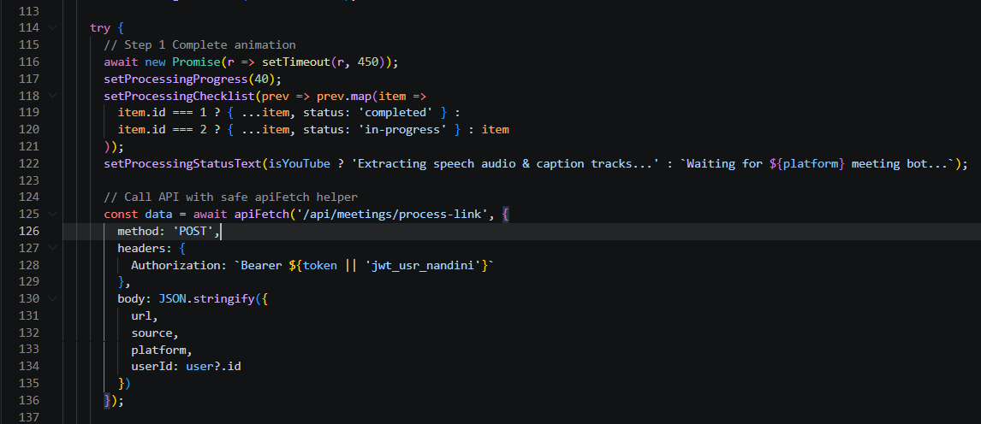

Milestone 3: Backend and Intelligence
Milestone 3 focuses on server-side orchestration and AI-powered meeting intelligence. The Express application provides REST API routes for authentication, meeting management, transcript processing, AI analysis, bot management, updates, deletion, and meeting-specific operations. The AI analysis layer extracts structured information from transcripts, while the persistence layer stores completed meeting records and exposes the results to the frontend.

Activity 3.1: REST API Routes
The Express backend implements REST API routes for authentication, meeting management, transcript processing, AI analysis, bot management, and meeting updates.
- Authentication routes: POST /api/auth/login, POST /api/auth/signup, POST /api/auth/oauth-mock, and GET /api/auth/me handle login, registration, demo OAuth, and current-user retrieval.
- Meeting routes: GET /api/meetings returns meeting history, GET /api/meetings/:id retrieves a specific meeting, PUT /api/meetings/:id updates meeting information such as action-item status or follow-up messages, and DELETE /api/meetings/:id removes a meeting.
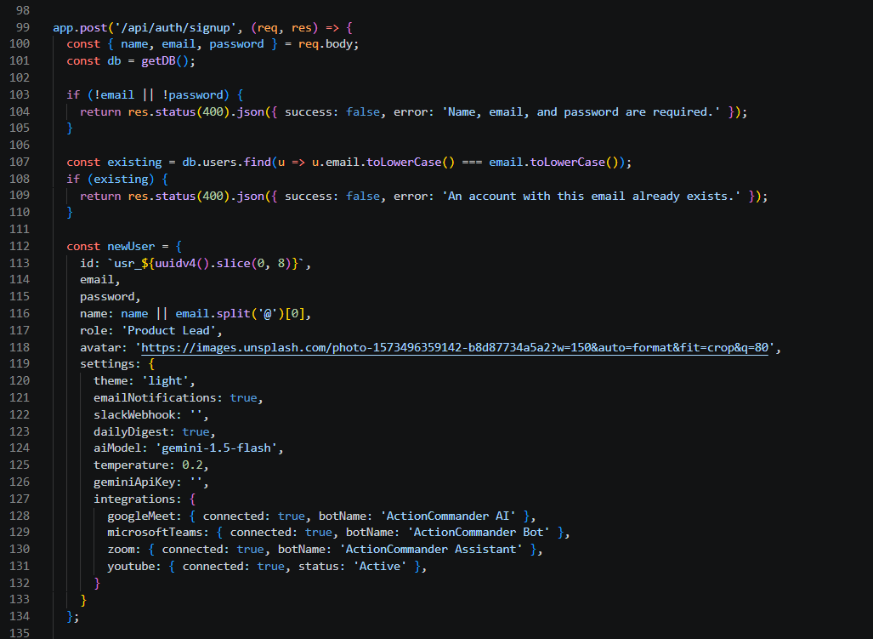

Activity 3.2: Transcript Analysis
The AI analysis layer processes the generated transcript and extracts meaningful meeting intelligence. The Precision Contextual NLP Engine focuses on identifying explicit and actionable information while filtering out general conversation and non-actionable statements.
- Decision extraction: Identifies explicit agreements, formal decisions, consensus statements, and important meeting decisions.
- Action-item extraction: Identifies future-oriented commitments, assigned responsibilities, and agreed deliverables.
- Owner identification: Determines the person or team responsible for an action item using delegation, first-person commitments, or accepted requests.
- Deadline extraction: Identifies explicitly stated dates, times, and other temporal commitments. When no deadline is stated, it remains Not specified.
- Risk detection: Identifies genuine blockers, dependencies, technical issues, and schedule-related risks.
- AI result validation: Gemini-generated results are validated and post-processed to ensure that decisions, action items, owners, deadlines, and risks are grounded in the transcript.

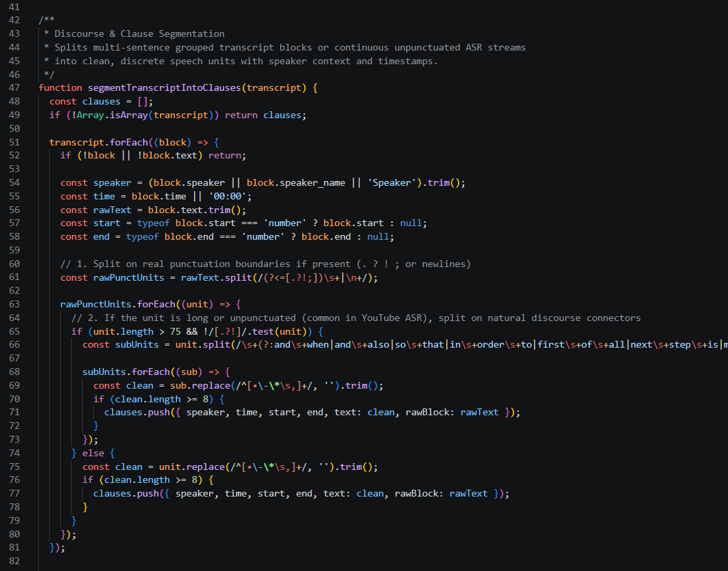

Activity 3.3: Meeting Persistence and Structured Results
After transcript processing and AI analysis are completed, the application creates and stores a structured meeting record in the local JSON database.
- Meeting persistence: Completed meetings are stored with information such as title, source, date, duration, participants, transcript, analysis, decisions, action items, owners, deadlines, risks, and follow-up information.
- Structured results: The backend organizes the AI output into structured fields including decisions, actionItems, owners, deadlines, risks, unansweredQuestions, importantTopics, meetingScore, and followUpMessage.
- Database update: The meeting record is saved through the application's JSON persistence layer so that it can be retrieved later.
- Frontend access: The backend returns the structured meeting object to the React frontend, where the information is consumed by the Results Dashboard, My Meetings, and Reports pages.
- Result updates: Stored meeting information can subsequently be retrieved or updated through the corresponding REST API routes.
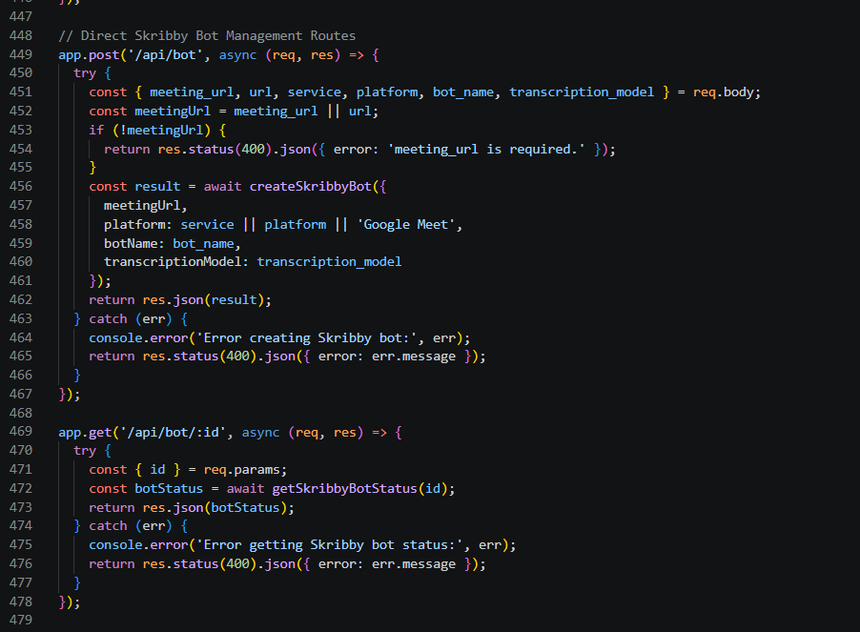

Milestone 4: Frontend Development
Milestone 4 focuses on the user experience. The frontend provides a light, workspace-style interface with a persistent sidebar and header, page-level navigation, cards, tables, badges, charts, transcript timelines, and responsive layouts.

Activity 4.1: Frontend Pages and User Interface
Build the complete frontend interface, including the login and application shell, home dashboard, transcript generation, processing screen, transcript review, results dashboard, My Meetings, Calendar, Reports, and Settings pages. The interface provides responsive layouts, navigation, cards, tables, badges, charts, transcript timelines, meeting metrics, structured results, and user interaction controls.
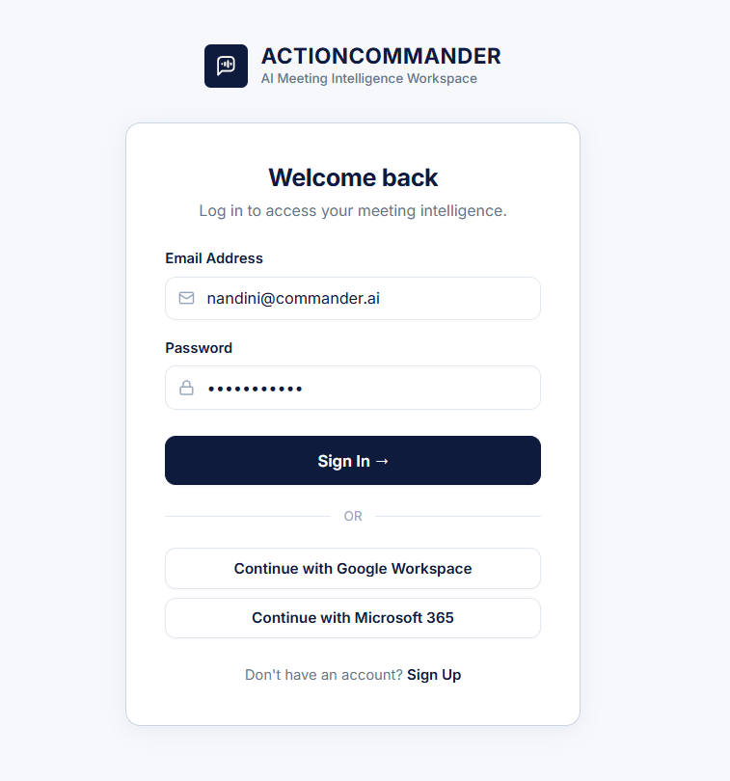
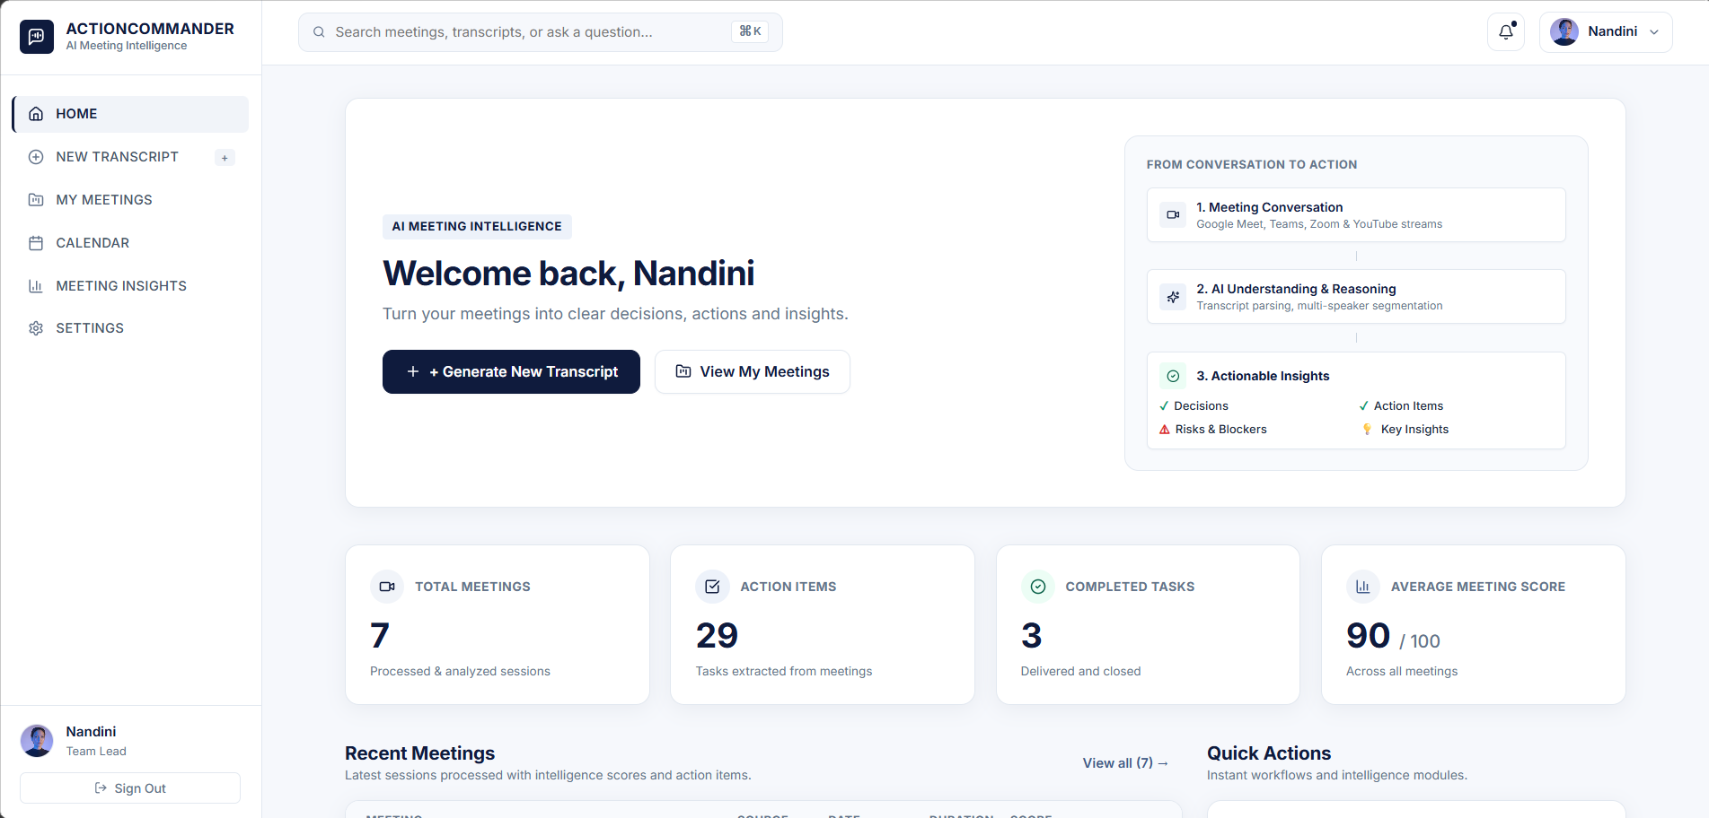

Activity 4.2: Frontend State Management and Backend Integration
Connect the frontend pages to the backend REST APIs using MeetingContext, AuthContext, and apiClient. Implement authentication persistence, meeting and transcript processing, bot-status polling, active meeting state, source and platform selection, error handling, toast notifications, result updates, and local storage persistence for relevant application state.
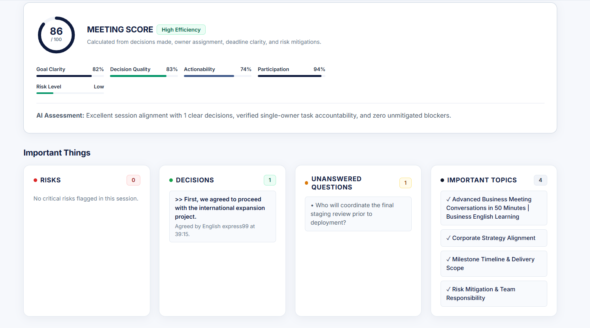

Milestone 5: Persistence, Testing, and Deployment
Module 5 focuses on testing, validation, and deployment of the AI Meeting-to-Action Commander. It verifies the complete application workflow, including authentication, meeting-link processing, transcript generation, AI analysis, result display, and data persistence. The module also ensures that frontend and backend components work correctly together and prepares the application for deployment and real-world usage.

Activity 5.1: Development and Production Commands
• Start both applications: npm run dev
• Start server only: npm run server
• Start Vite client only: npm run client
• Build frontend: npm run build
• Preview production build: npm run preview
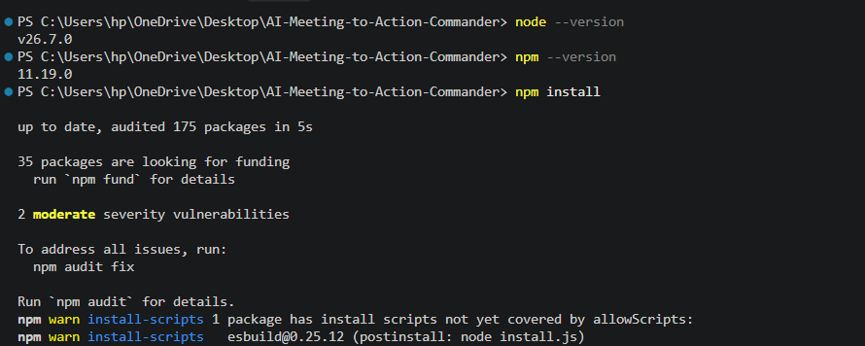

Activity 5.2: Functional Test Scenarios
• Test 1 — Authentication: Sign in with valid credentials, refresh the browser, verify the session remains available, then log out and confirm the login page returns.
• Test 2 — YouTube validation: Submit an invalid URL and verify a clear validation error. Submit a public YouTube video with captions and verify transcript generation.
• Test 3 — Transcript quality: Confirm timestamps, speaker labels where available, duration, language information, search, copy, and TXT/MD export.
• Test 4 — AI analysis: Verify decisions, action items, owners, deadlines, risks, unanswered questions, important topics, meeting score, and follow-up message are populated from transcript evidence.
• Test 5 — Action item filtering: Use transcript examples containing greetings, explanations, suggestions, and vague discussion to verify that they are not incorrectly promoted to tasks.
• Test 6 — Live meeting bot: With the meeting-bot credentials configured, verify joining/status transitions and transcript completion for Google Meet, Teams, or Zoom.
• Test 7 — Ask AI: Ask a question whose answer is present in the meeting and then ask an unrelated question. Confirm that the answer remains grounded to the selected meeting.

Exploring the Website’s Web Pages:

Login Page:
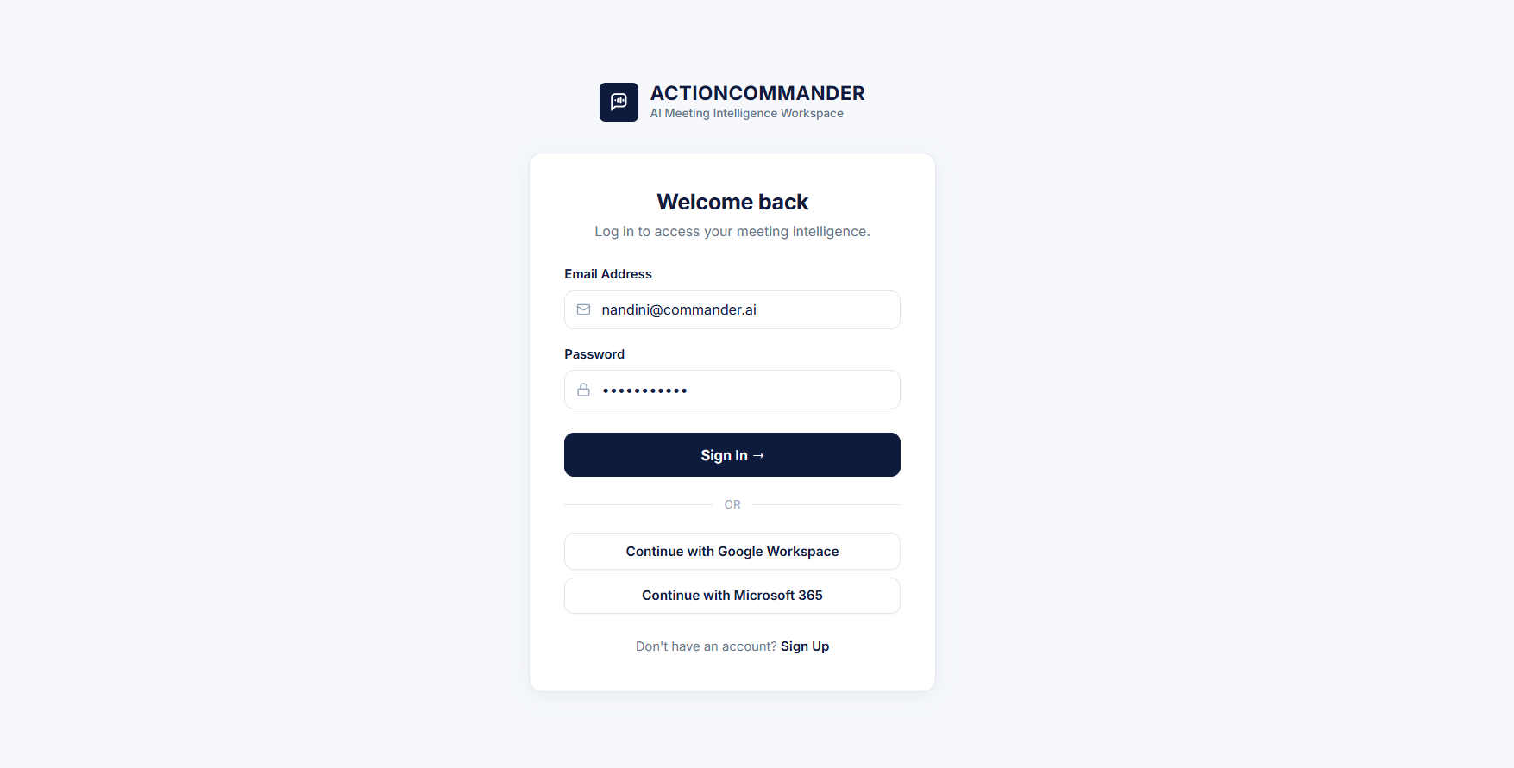

Description: The Login Page is the entry point of the AI Meeting-to-Action Commander application. It allows registered users to securely access their meeting workspace using their email address and password. The page also supports a sign-up mode for new users and provides simplified sign-in options for Google Workspace and Microsoft 365. After successful authentication, the application stores the authenticated user information and redirects the user to the main application dashboard.

Home / Meeting Intelligence Dashboard:

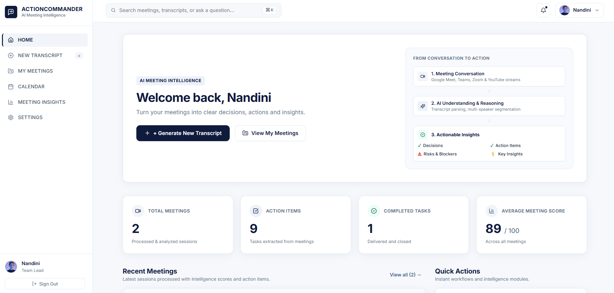
Description: The Home Dashboard acts as the central workspace of the application after the user successfully logs in. It provides an overview of the user's meeting activity and gives quick access to the major features of the platform. The dashboard contains a prominent Generate New Transcript action for starting a new meeting analysis and a shortcut for viewing previously processed meetings. It also displays key meeting metrics such as the total number of meetings, action items, completed tasks, and average meeting score.

Generate New Transcript Page:

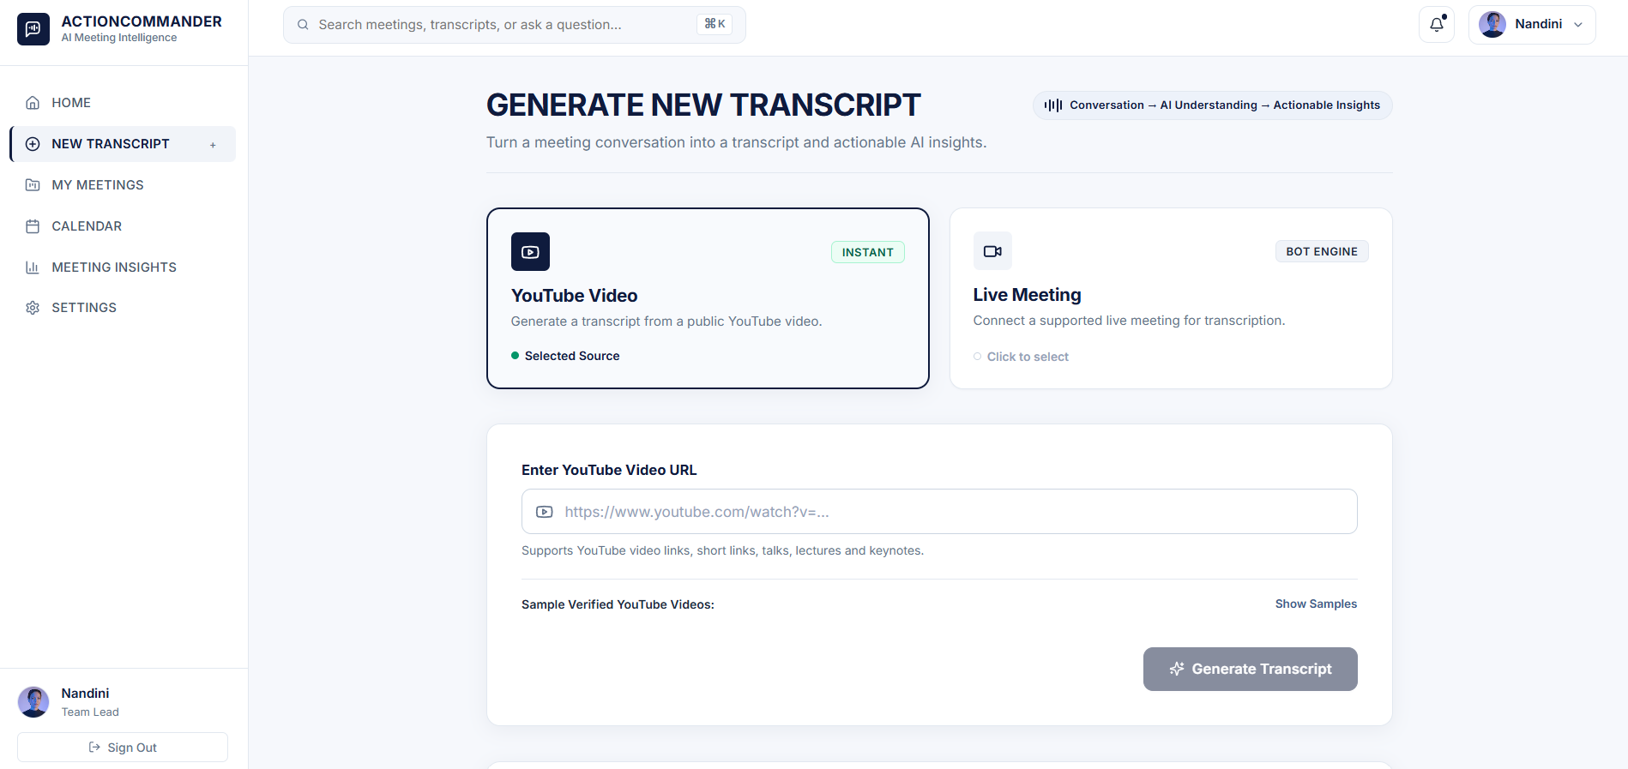

Description: The Generate New Transcript page allows users to generate meeting intelligence from a publicly available YouTube video. The user provides the YouTube video URL through the input field and starts the processing workflow. The application validates the submitted URL before sending the request to the backend. The generated transcript is subsequently analyzed to identify decisions, action items, owners, deadlines, risks, unanswered questions, important topics, and other meeting insights.

Transcript Page:
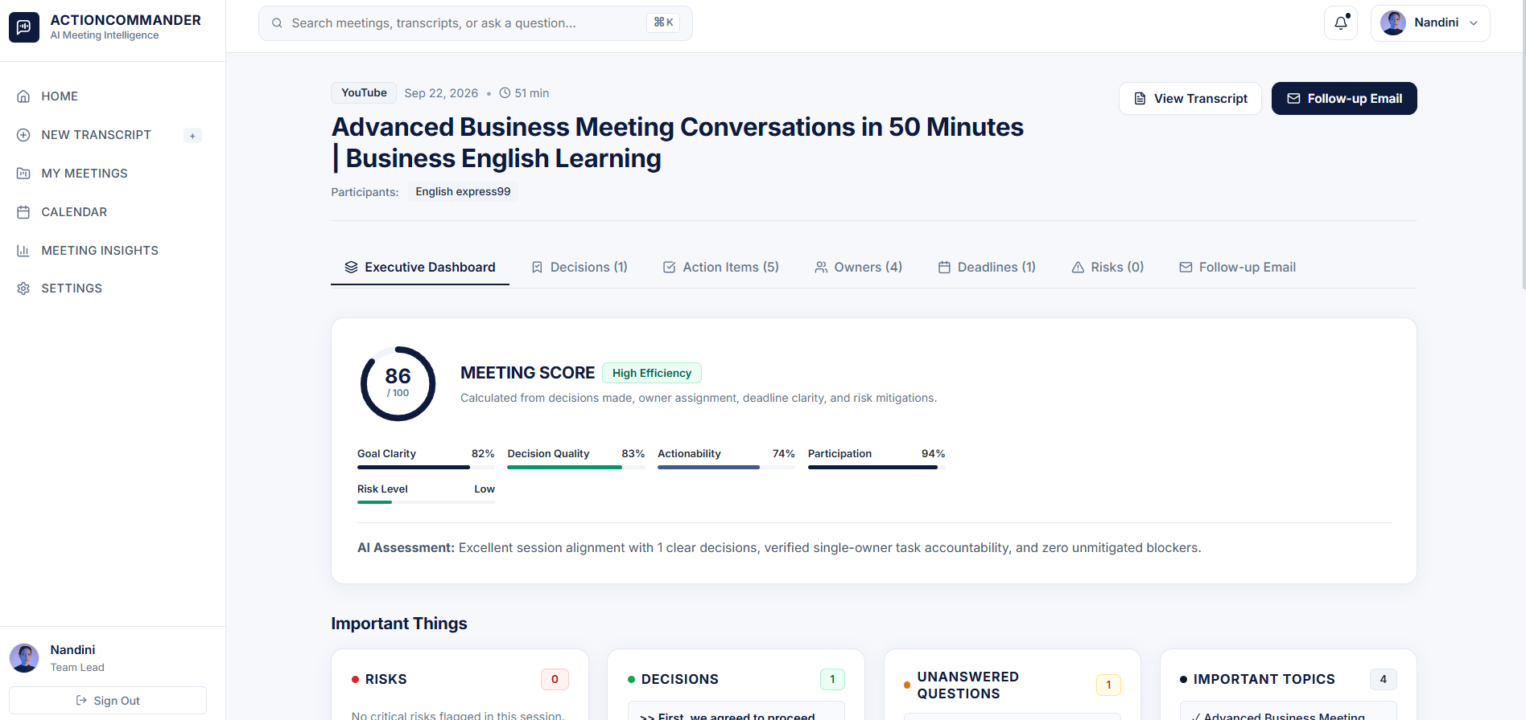
Description: The Transcript Timeline page provides a detailed view of the generated meeting transcript. It displays meeting metadata such as the meeting title, participants, duration, and language information along with the conversation itself. Transcript content is organized into timestamped speech blocks so that users can follow the meeting chronologically and identify who said particular statements. The page also provides transcript search functionality, allowing users to locate specific speakers or conversation content. Relevant moments can be identified through tags, while copy and export controls allow users to reuse or save transcript information. From this page, users can proceed to the AI-generated meeting analysis.

Results Dashboard:
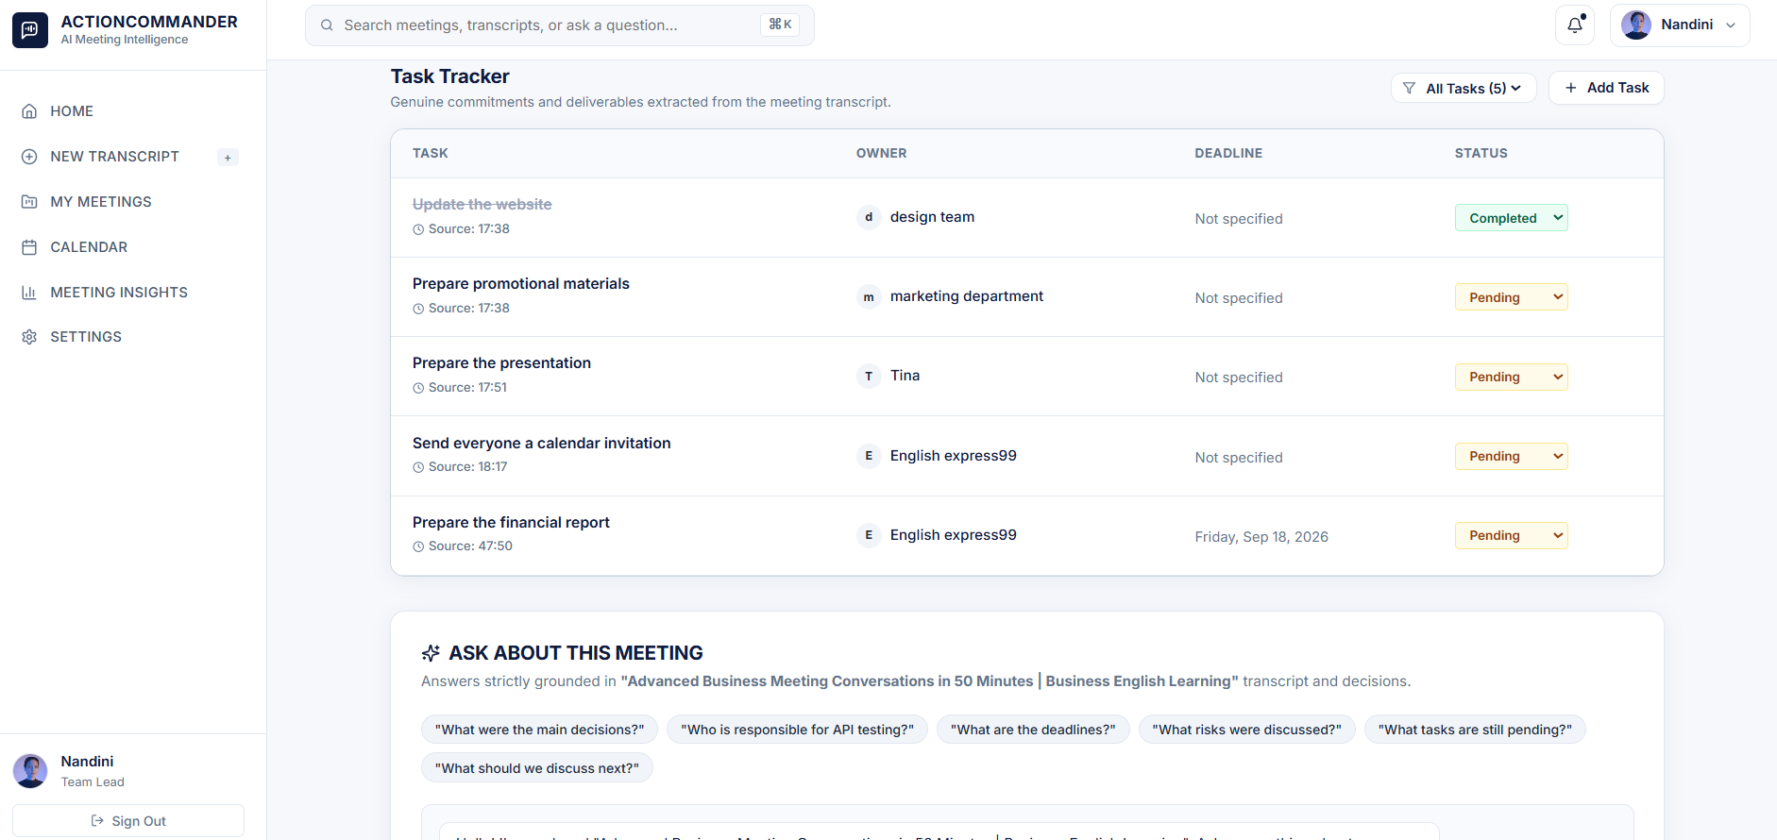

Description: The Results Dashboard presents the structured intelligence extracted from the processed meeting transcript. It provides an overall meeting score together with an explanation of the score and organizes the analysis into several categories. Users can review important decisions, action items, owners, and deadlines identified from the conversation. The dashboard also highlights risks and blockers, unanswered questions, and important topics discussed during the meeting. In addition, the application generates a follow-up message based on the meeting outcomes. Action-item statuses can be modified through the interface and saved through the backend, allowing the results to remain useful after the initial analysis.

Calendar:
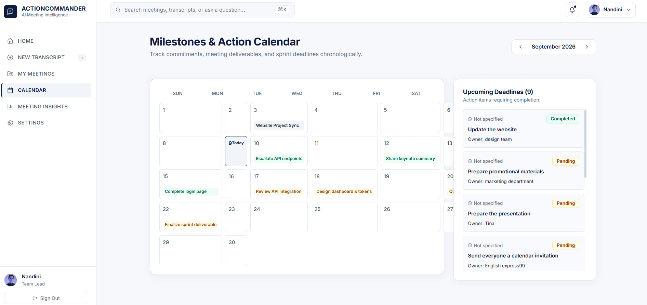

Description: The Calendar page provides a workspace for displaying meeting schedules and related commitments within the application. It organizes meeting-related information in a calendar-based interface so that users can view upcoming schedules and associated meeting information. The page complements the meeting-history and intelligence features by providing a scheduling-oriented view of the user's meeting workspace.

Settings:

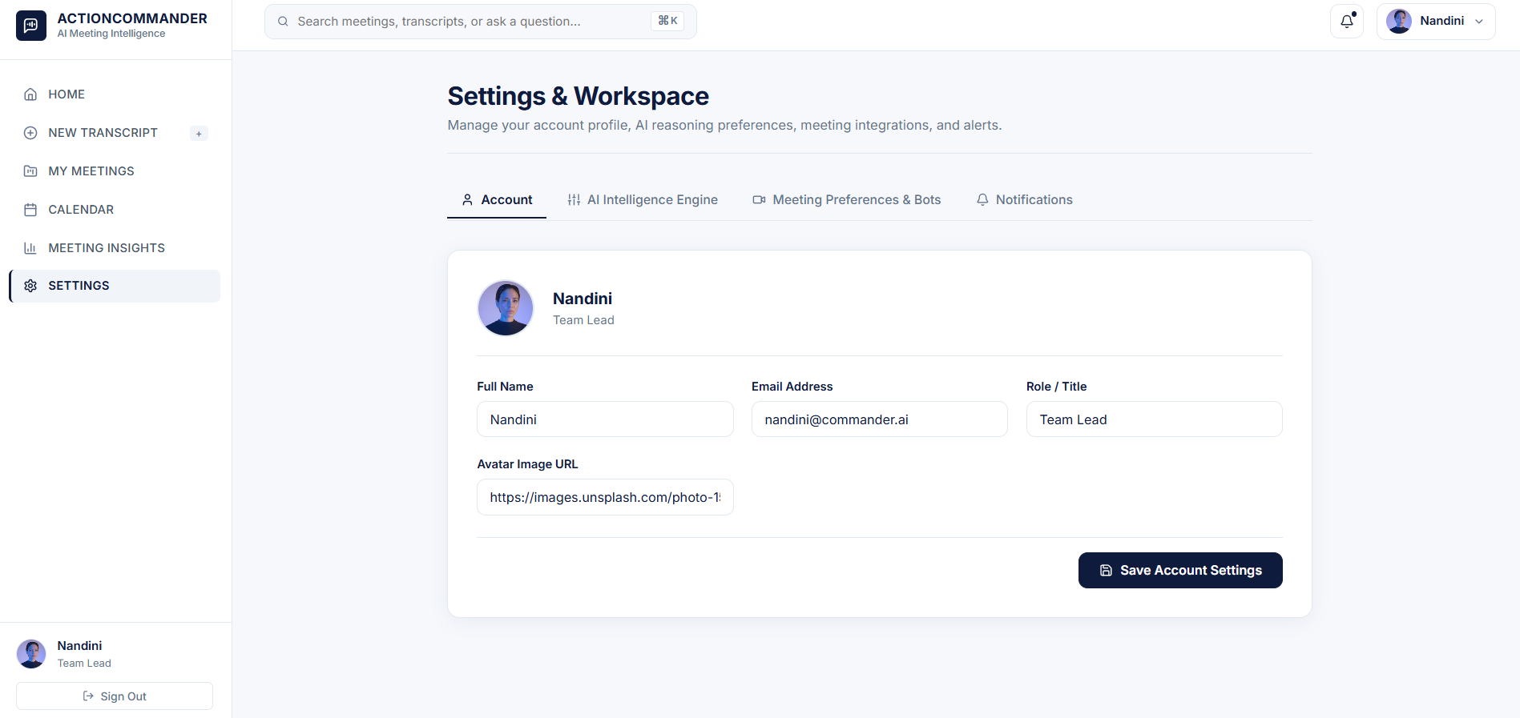

Description: The Settings page provides a centralized interface for managing the application's user, AI, and meeting-integration preferences. It allows users to configure AI-related options such as the Gemini model and temperature settings, while also providing information about the supported meeting-platform connectors, including their integration and connection status. The page helps users customize the application according to their requirements and manage the configuration used for meeting processing and AI-based analysis.

Conclusion:
AI Meeting-to-Action Commander is a full-stack meeting intelligence application that connects meeting or video ingestion with transcript processing, structured AI analysis, and an action-oriented workspace. Its React/Vite frontend guides users from authentication through source selection, processing, transcript review, and structured results, while the Express backend coordinates validation, transcript services, AI analysis, persistence, bot management, and meeting-specific question answering.
The project combines configurable Gemini-based analysis with a Precision Contextual NLP fallback so that the intelligence layer can continue to operate when the external LLM path is unavailable. Its strict action-item rules emphasize future commitments, real evidence, owners, and stated deadlines rather than turning ordinary discussion into tasks. The application also preserves transcript evidence and supports risks, decisions, unanswered questions, important topics, meeting scoring, and executive follow-up generation.
For the final submission, the most important visual evidence should come from the working application's Login, Home, Generate New Transcript, Processing, Transcript, Results Dashboard, My Meetings, Reports, Calendar, and Settings screens. The code figures in this documentation provide representative implementation evidence for the main backend, transcript, AI, state-management, and QA flows.

